 | INPUTS |  |  |  |  |  |  |  | OUTPUTS
 | Enable |  |  | Select
G1 | G2A’ | G2B’ | A2 | A1 | A0 | Y₀’ | Y₁’ | Y₂’ | Y₃’ | Y₄’ | Y₅’ | Y₆’ | Y₇’
1 | 0 | 0 | 0 | 0 | 0 | 1 | 0 | 0 | 0 | 0 | 0 | 0 | 0
1 | 0 | 0 | 0 | 0 | 1 | 0 | 1 | 0 | 0 | 0 | 0 | 0 | 0
1 | 0 | 0 | 0 | 1 | 0 | 0 | 0 | 1 | 0 | 0 | 0 | 0 | 0
1 | 0 | 0 | 0 | 1 | 1 | 0 | 0 | 0 | 1 | 0 | 0 | 0 | 0
1 | 0 | 0 | 1 | 0 | 0 | 0 | 0 | 0 | 0 | 1 | 0 | 0 | 0
1 | 0 | 0 | 1 | 0 | 1 | 0 | 0 | 0 | 0 | 0 | 1 | 0 | 0
1 | 0 | 0 | 1 | 1 | 0 | 0 | 0 | 0 | 0 | 0 | 0 | 1 | 0
1 | 0 | 0 | 1 | 1 | 1 | 0 | 0 | 0 | 0 | 0 | 0 | 0 | 1
DLD LAB 08 SUBMISSION
NAME: YASH RAJ
ROLL NUMBER: 24K-0737
Task#1:

Logisim implementation:
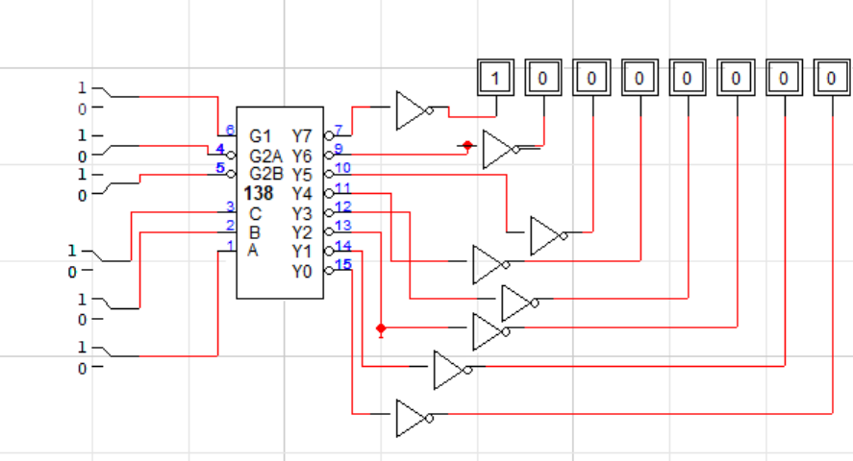

Task#2:
D | C | B | A | Display | a | b | c | d | e | f | g
0 | 0 | 0 | 0 | 0 | 1 | 1 | 1 | 1 | 1 | 1 | 0
0 | 0 | 0 | 1 | 1 | 0 | 1 | 1 | 0 | 0 | 0 | 0
0 | 0 | 1 | 0 | 2 | 1 | 1 | 0 | 1 | 1 | 0 | 1
0 | 0 | 1 | 1 | 3 | 1 | 1 | 1 | 1 | 0 | 0 | 1
0 | 1 | 0 | 0 | 4 | 0 | 1 | 1 | 0 | 0 | 1 | 1
0 | 1 | 0 | 1 | 5 | 1 | 0 | 1 | 1 | 0 | 1 | 1
0 | 1 | 1 | 0 | 6 | 1 | 0 | 1 | 1 | 1 | 1 | 1
0 | 1 | 1 | 1 | 7 | 1 | 1 | 1 | 0 | 0 | 0 | 0
1 | 0 | 0 | 0 | 8 | 1 | 1 | 1 | 1 | 1 | 1 | 1
1 | 0 | 0 | 1 | 9 | 1 | 1 | 1 | 1 | 0 | 1 | 1
Logisim implementation:
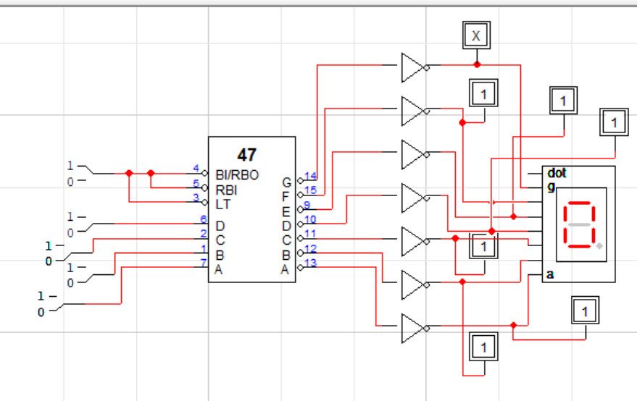
Task#3:
Logisim Implementation:
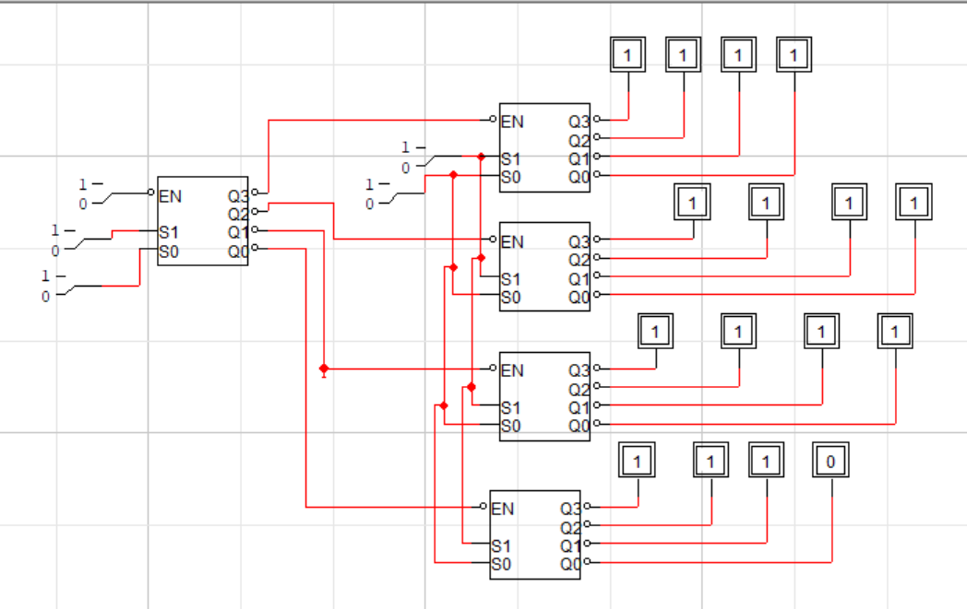
Hardware Lab Task:
